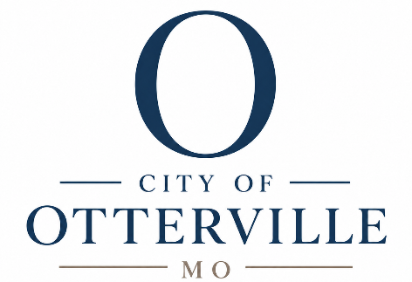

203 BB Highway PO Box 58 Otterville, MO 65348 660.366.4613 ottervillecityclerk@ottervillemo.gov
Posted

October 2nd 2026 12:05 PM
Tentative Agenda
Board of Alderman
Regular Meeting
Where: City Hall
When: October 7th, 2026
6:00 PM
- Roll call Sean Main roll call
- Approve Agenda Sean Main vote
- Approval of minutes from last meeting Sean Main vote
- Approval of Monthly bills Sean Main vote
- Financial Report Sean Main information
- Mayor’s Comments: Sean Main
- Special Guest
- Citizen Concerns
- Old Business:
  - Clerk’s Conference Sean Main vote
- New Business:
  - Budget Sean Main vote
  - TNR program Sean Main vote
  - City vehicle maintenance policy Sean Main vote
  - Police car maintenance Sean Main vote
  - Employee handbook insert Sean Main vote
  - Fall clean up Sean Main vote
  - Maintenance vehicle Sean Main vote
- Meeting Adjourned Sean Main roll call

